Steps to assign mechanical key to keypad in Delious Machine
      - Go to MENU > PROGRAMMING > PRESET. Tap on Mechanical Key

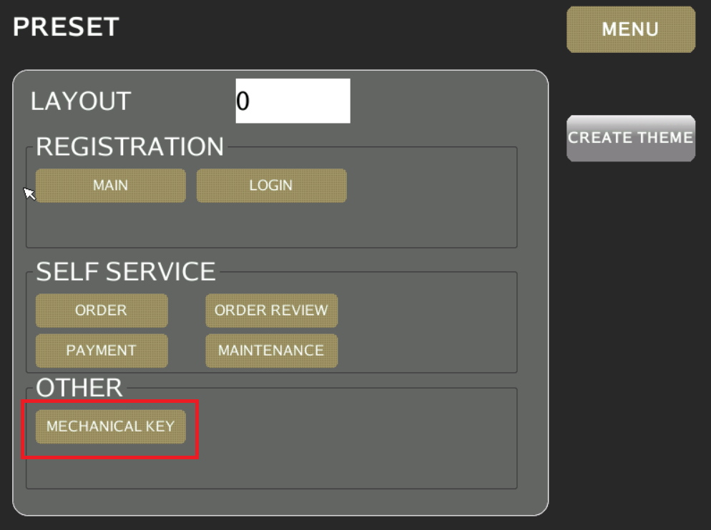

      - Tap on the highlighted to choose Preset key group

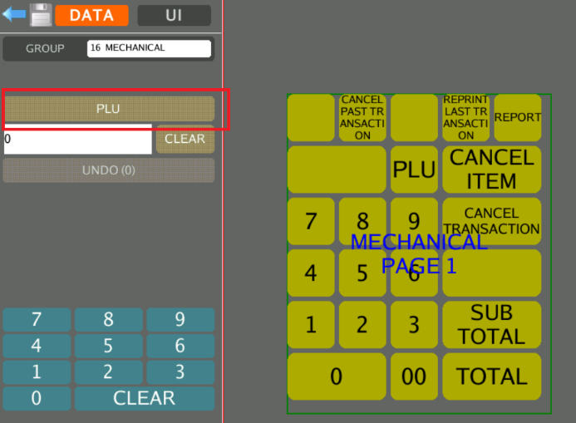

      - A list of PRESET KEY group displayed.

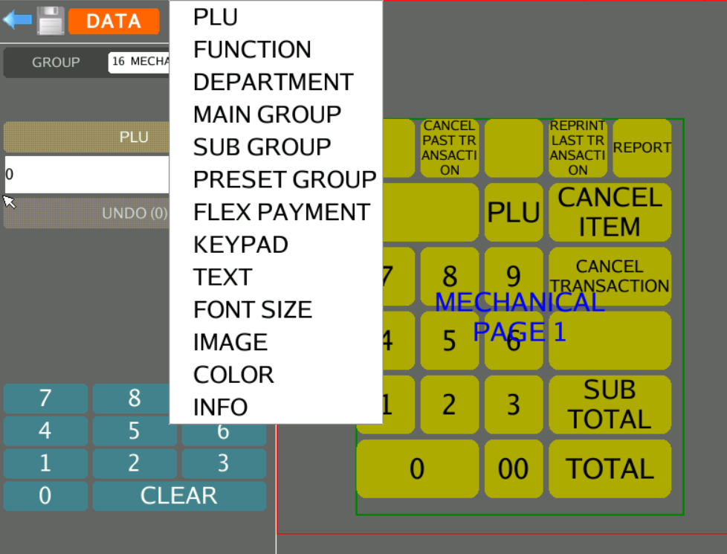
      - Sample of assigning preset key to mechanical key pad. E.g. Assign 30008 PLU to the assigned key pad

